As we move into June the Club has already opened its doors to allow members to meet indoors. On the 17th May the Committee implemented the revised Government guidelines for the Café and the Bar with service at the table and all Covid precautions put into place. This has been reasonably successful with the Lounge now open on Friday and Saturday evenings from 5 pm with the seating plan in the Lounge socially distanced with table service. One lady was heard to say ‘isn’t it lovely to hear a buzz about the place and be able to dress up again to have a social drink’. As far as the Club is concerned ‘yes it is’ and as long as everybody keeps safe we can hopefully return to some sort of normality in the near future.

The Café is now located in the Main Hall and the Team have worked hard to deliver a reasonably priced varied menu. It has not been easy for the Staff to adopt new practices but credit where credits due they have all adapted well in these ever changing times. A variety of specials are available each day along with our well established main meals so if you have not visited our café previously, why not give it a try?

The 21st June is the next step forward when all or nearly all restrictions are removed. We will as usual continue to monitor the Covid guidelines and may wish to retain one or more of the current practices to ensure the safety of our members. More information will be provided when it is available.

The Annual General Meeting is likely to take place in July/August dependant on completion of our accounts by the Accountants. This is the time when we are looking for new Committee Members as three current occupants are scheduled to retire. Len Torr, Keith Norris and myself will take a well earned rest and allow younger members to take over. A nomination list will be placed on the notice board nearer the AGM date so if you are interested in becoming a Committee Member of a successful Social Club please put your name forward. We would also like nominations for the positions of President, Secretary, and Entertainment Secretary from members who have experience of club activities.

As reported in last month’s newsletter a reminder for your diary of events returning in June –

Line dancing – 21st June
Fitsteps - 22nd June
Weekly Quiz - 23th June
Bingo - 25th June

We are looking to run a Pilates class in the Club as several members have asked if it is possible. If you are interested in attending such a class in the Club please let me know and I will endeavour to provide an appropriate session by an approved instructor.

The snooker tables are now on a booking system and if you, as a member, wish to play on the tables book your session early. The relevant details are on the Clubs facebook page and web site.

The Bowls season is under way and there has been great activity on the Bowling Green. Saturday games are taking place as well as mid-week matches. The Ladies teams started on Tuesday along with one Vets side which means we will have thirteen teams representing Rolleston Club.

A big thank you to those Committee members and Staff who have re-decorated the areas behind both bars and for renewing the counter tops. The area already looks much brighter and we are awaiting for the Gin Bar to be finished in the Main Room to complete the project. Individuals have given up their free time to enhance the facilities for Rolleston Club and particularly the membership. Paid up membership has grown considerably during the past months, especially since the Club has reopened its doors. The saving of being a member equates to 30p pint of lager/beer and your membership fee is soon recouped. We are to check membership cards during June and anyone not paid their annual subscription will be removed as a member.

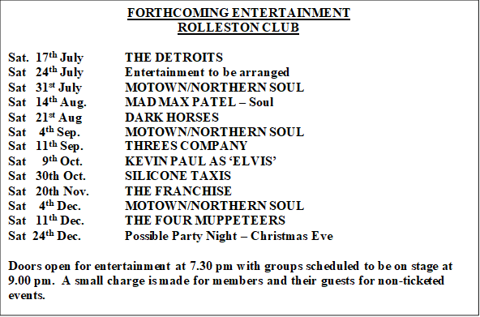For your information I list below all dates for entertainment evenings booked to the end of the year. A varied selection of bands and the return of ‘Elvis’ after the success of his performance prior to lockdown are two of the scheduled events.

We have a Facebook page Rolleston Club and a Twitter account @Rolleston_Club for up to date news and our website, www.rollestonclub.org.uk is now also live. Join in our conversation

John Brandon
Club Secretary

